Charlie’s Bar at GW Village Hall Open every Thursday 6pm to 10pm
July Events.
4th July: American Independence Night
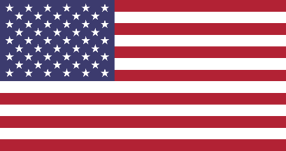
Come and join us for a bit of fun, some yankee music, perhaps a sing-along and try a bit of American Line Dancing with
Kara’s School of Dance.
Coming soon:
11th July: 7.30pm “The Heartwarming Story
of Crommie the War Dog”
Admission Free. Bar open from 6pm as usual.
If you have suggestions for events or open mic sessions,
run your ideas past Charlie and book your spot on 07866 168051.

